**Website for a College English course**

Responsive WordPress site developed with Local by Flywheel, Sublime Text 3, and Git Bash

Home Page (using WP Queries and Glide.js Slideshow)

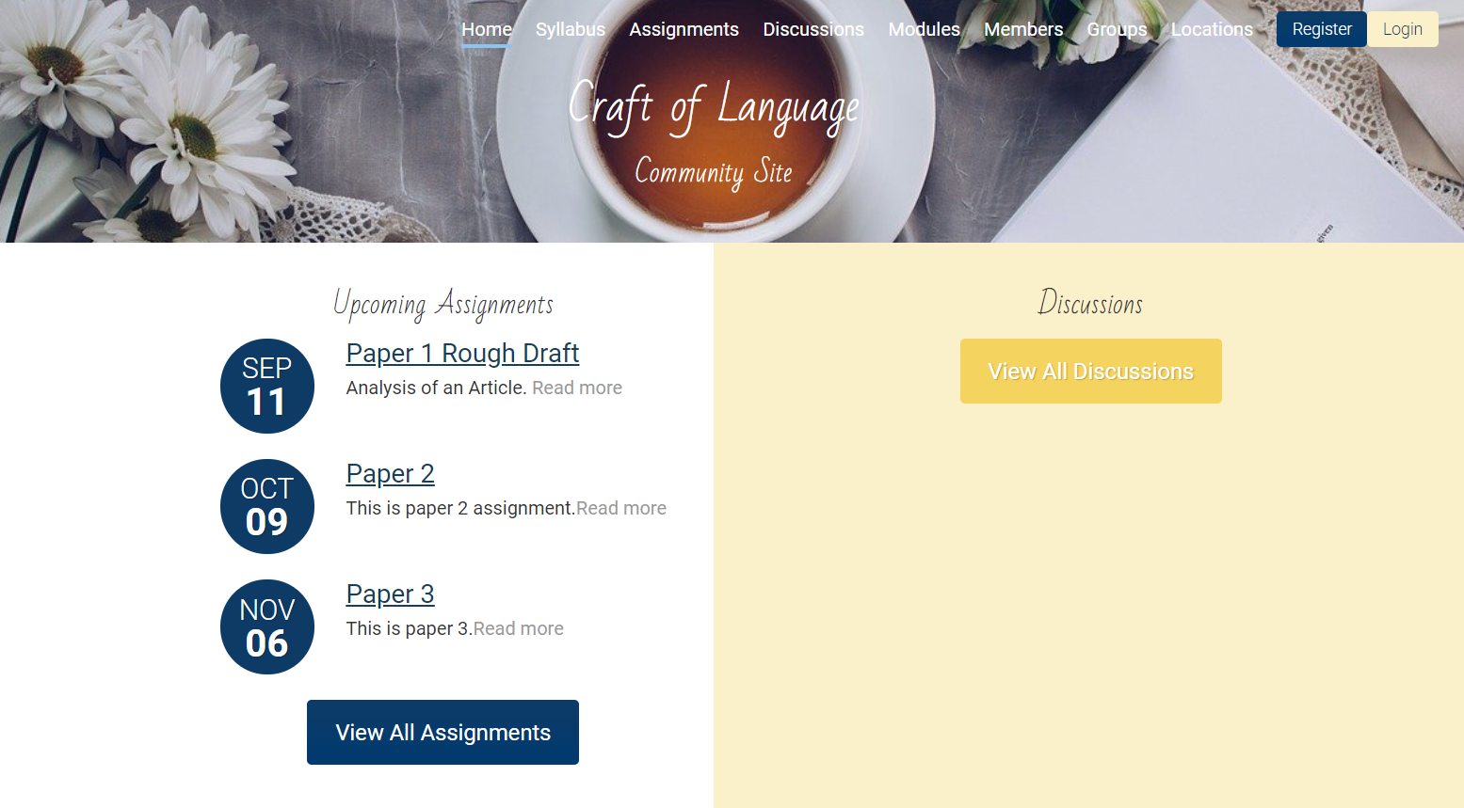

Home Page (iPhone X) Custom Login Screen

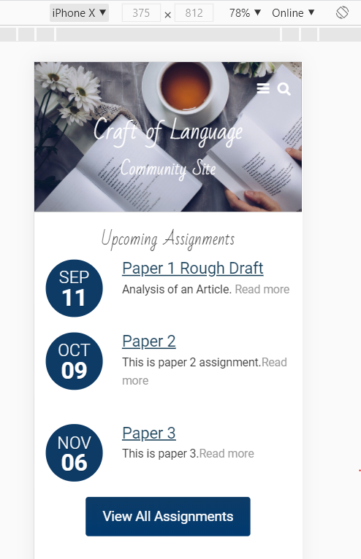

Final Grade Calculator using JavaScript

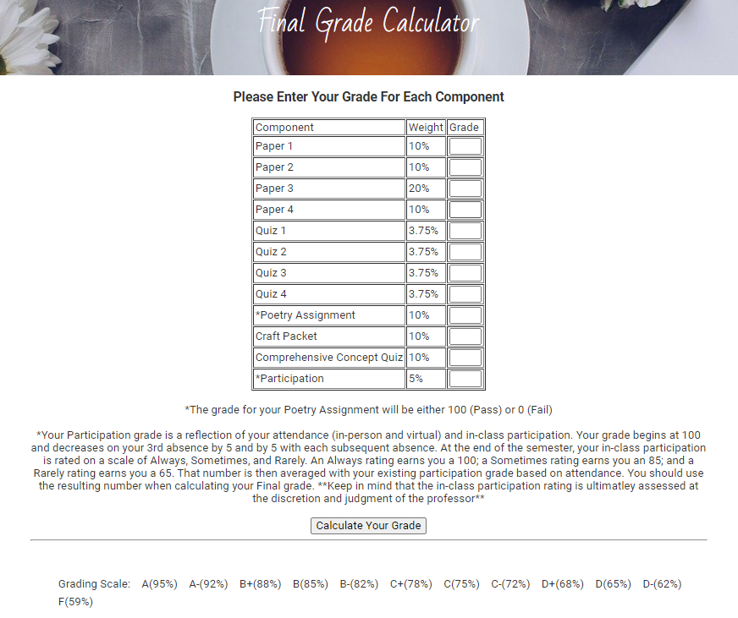

Submission Form using Contact Form 7 plugin secured with Intelligent reCAPTCHA

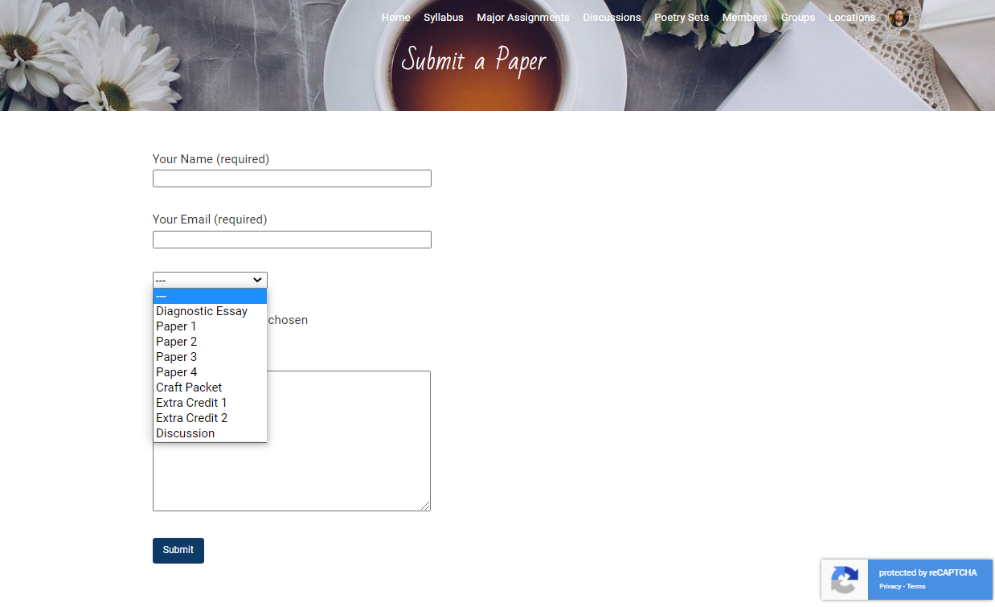

Locations Page incorporating Google Maps JavaScript API with relevant course locations (Classrooms, Library, Writing center, Office) pinned

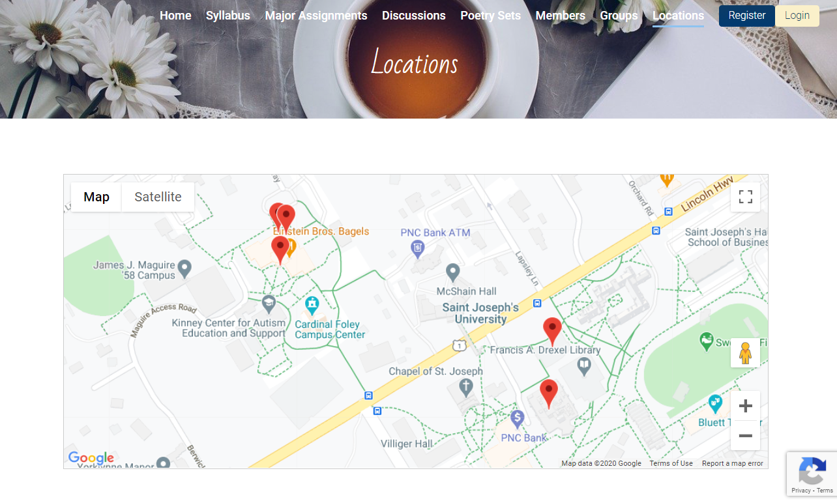

User Menu On-hover (when logged in)

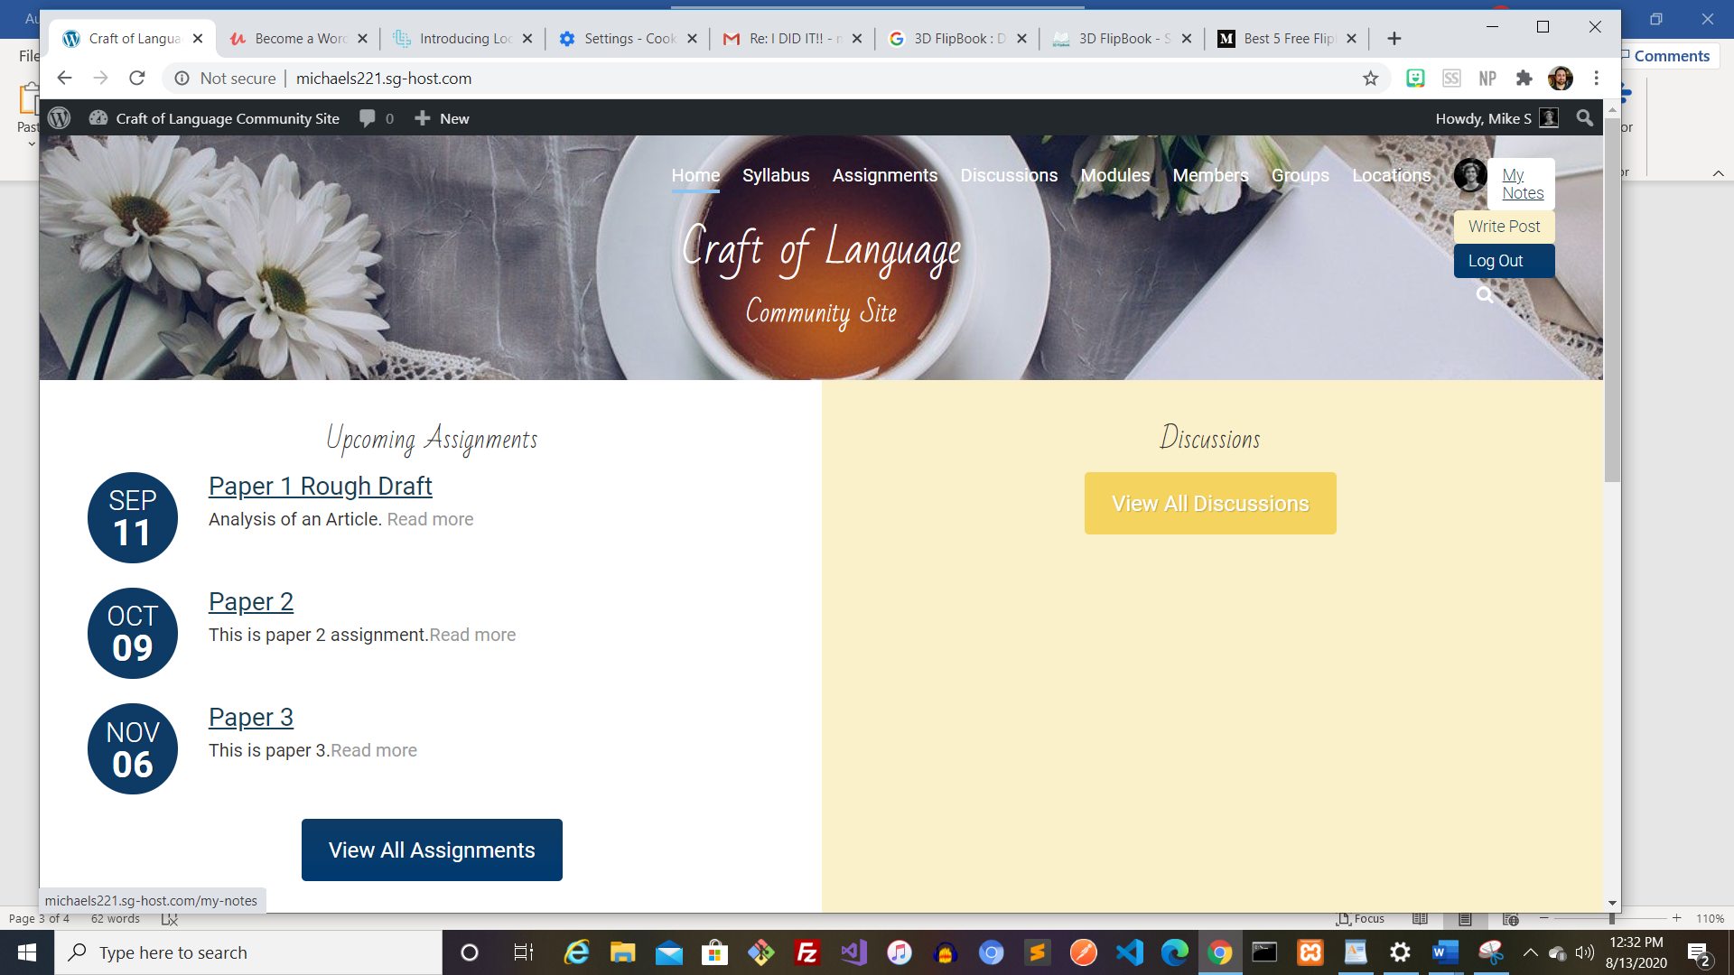

Member Profile Page (with Gravatar, Custom Page Banner, Author Posts, and Post Comments via WP Comments Query)



My Notes Feature using WordPress’s REST API

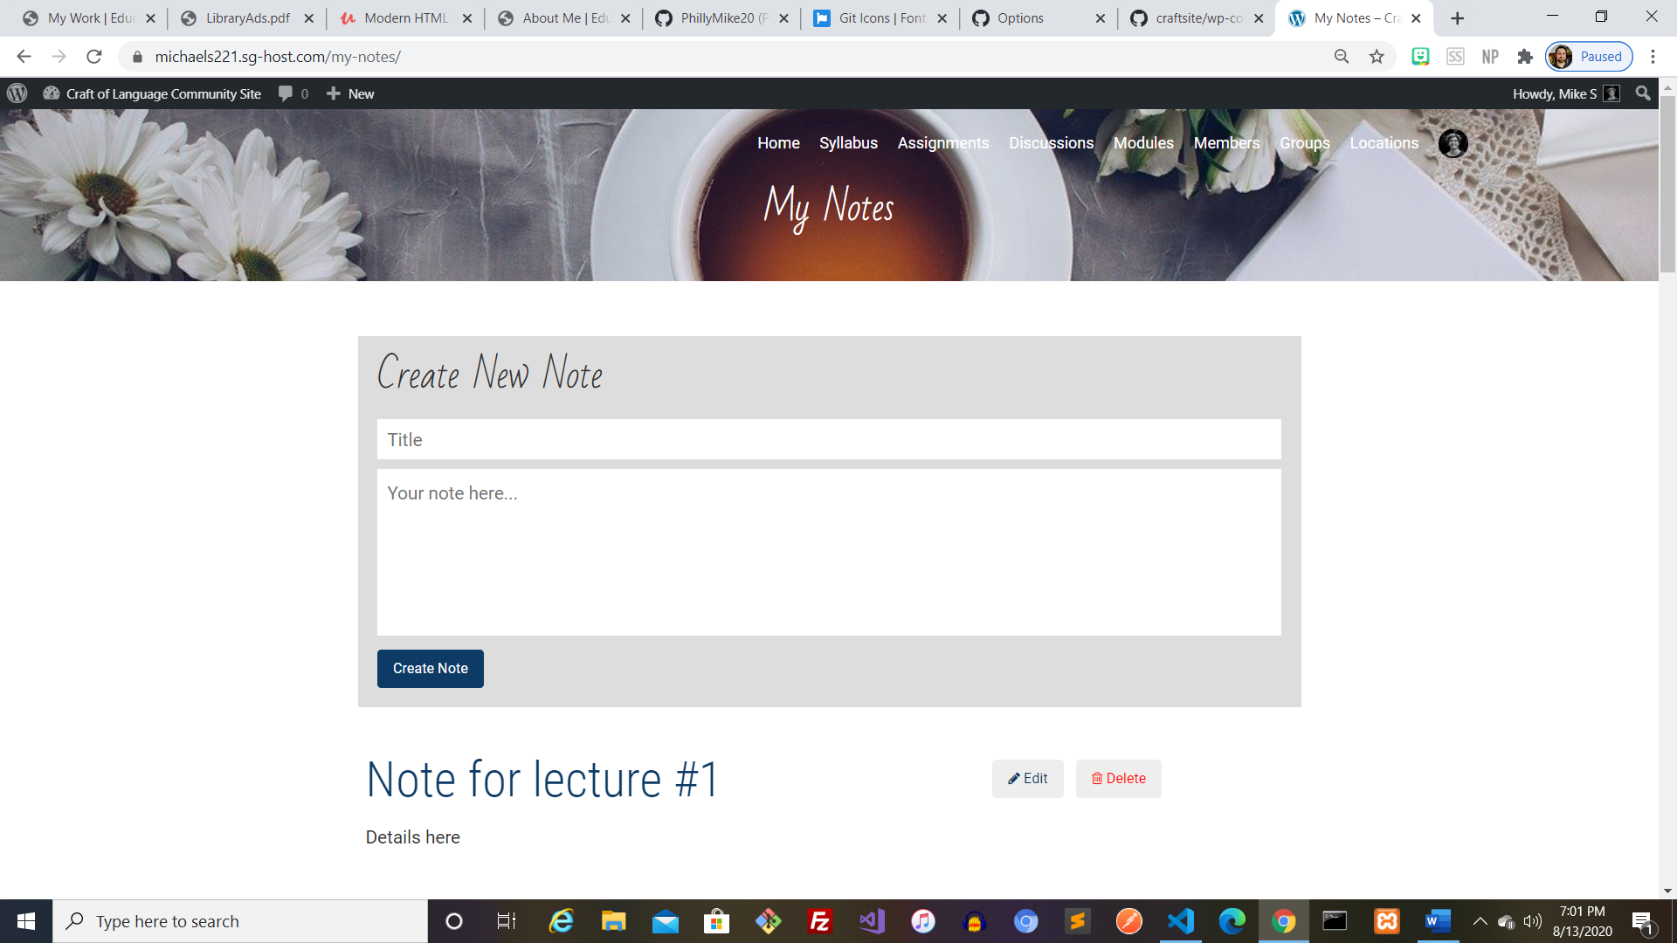

Member Post Page with Comment form using **wpDiscuz Plugin**

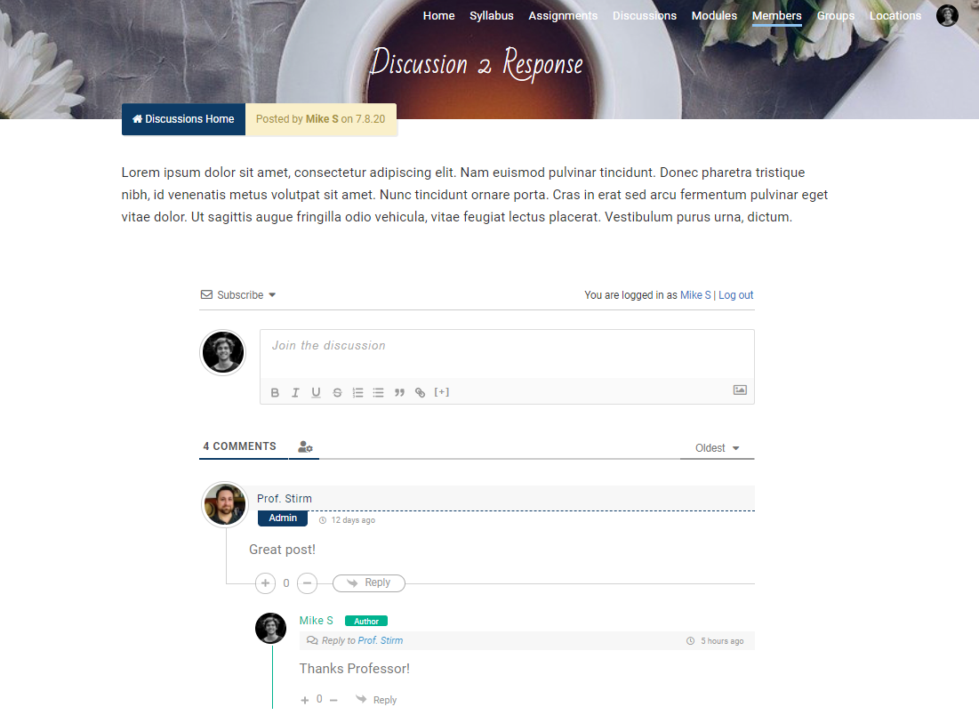

Class Page with Member Gravatars using **Author Avatars List/Block Plugin**



Group Page with Member Gravatars via WP User Query



Assignment Page with Rubric overview created with Screencast-O-Matic screen recorder, a related lecture, and resources for finding a speech

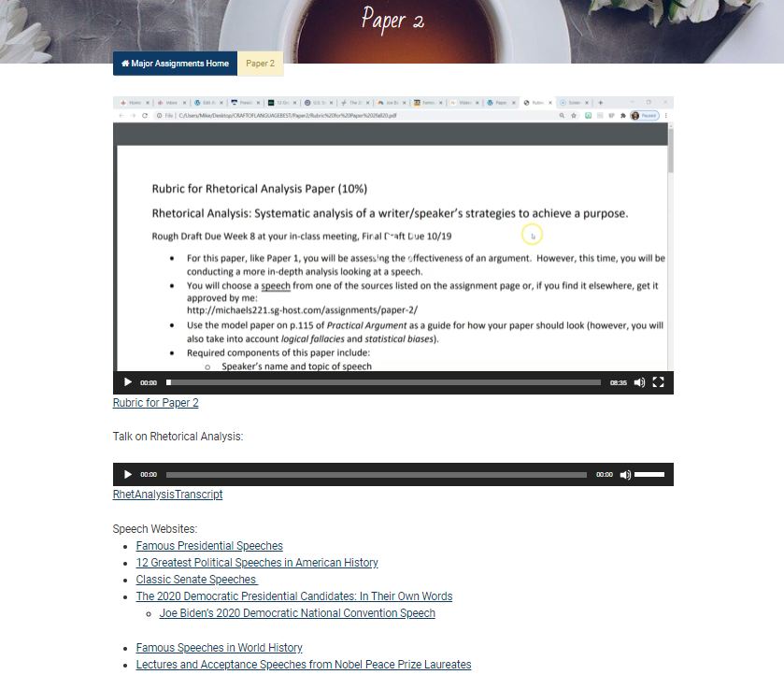

Discussion Page with related article PDFs and embedded survey from SurveyMonkey

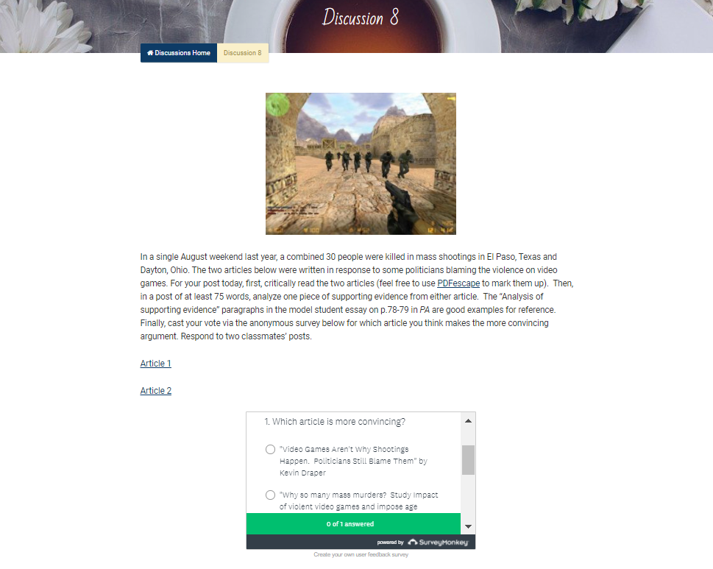

Discussion Post Streams via **Recent Posts Widget Extended Plugin**

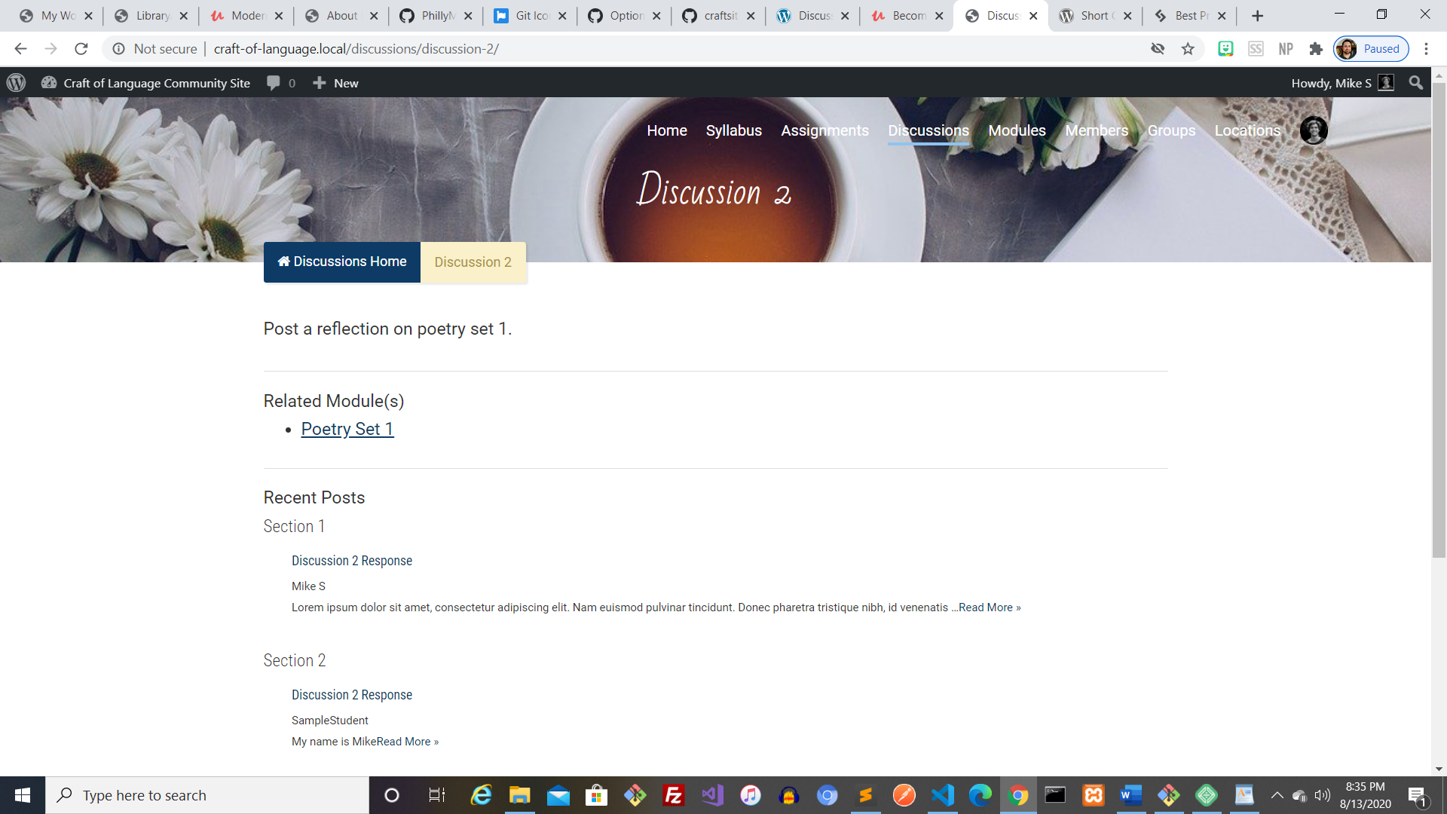

Poetry Set with embedded mp4 introduction recorded with Audacity, reading list, and related media

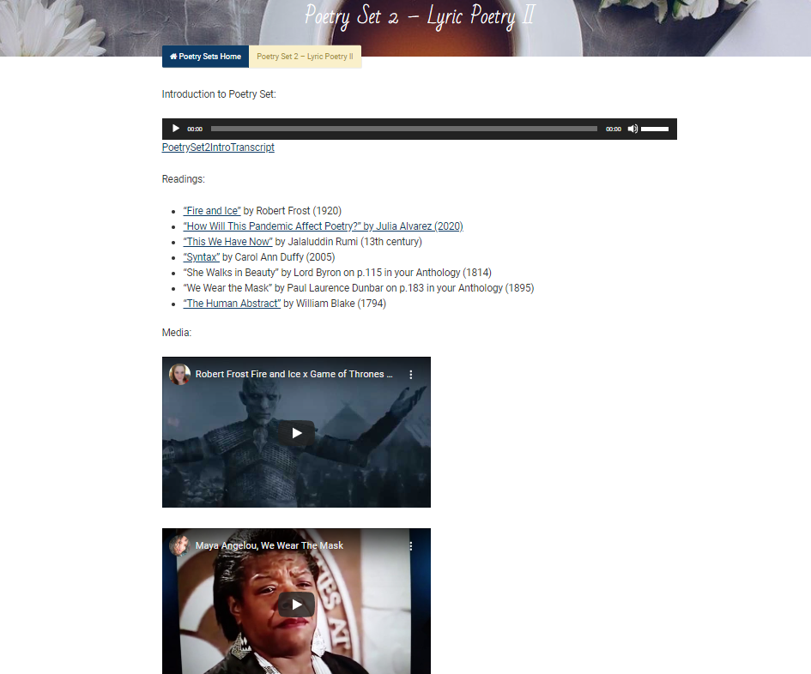

Writing Resources Page with “Top Twenty Tips for Editing” flipbook, common errors playlist via Video Gallery plugin, and additional resources like articles on grammar topics

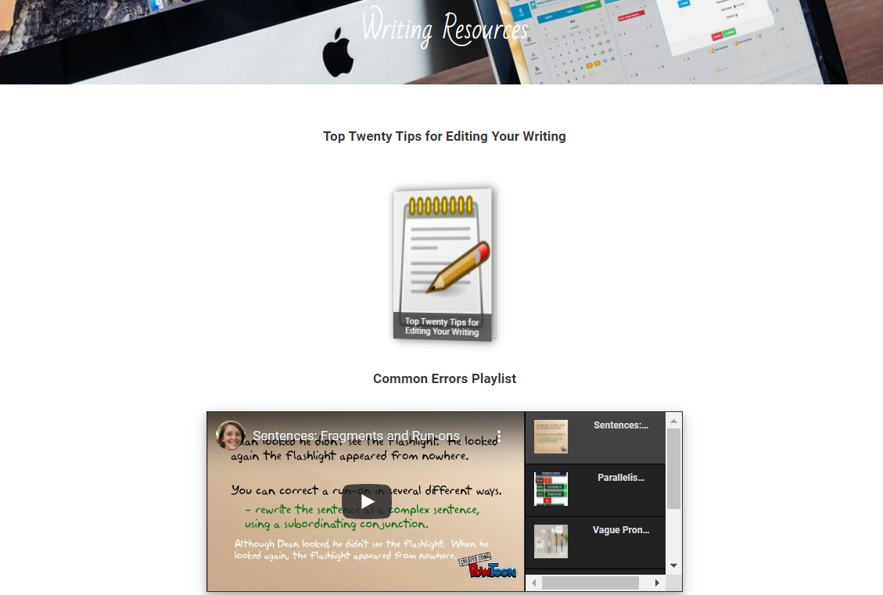

Archive of Course Videos using Lightbox Gallery

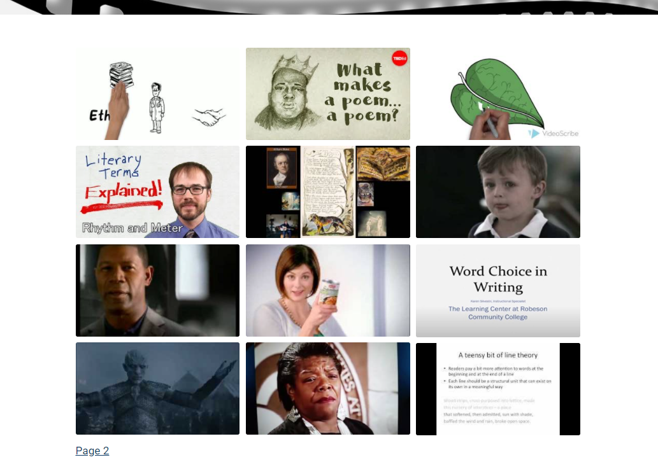

Class Poetry Collection via dFlip Books Plugin

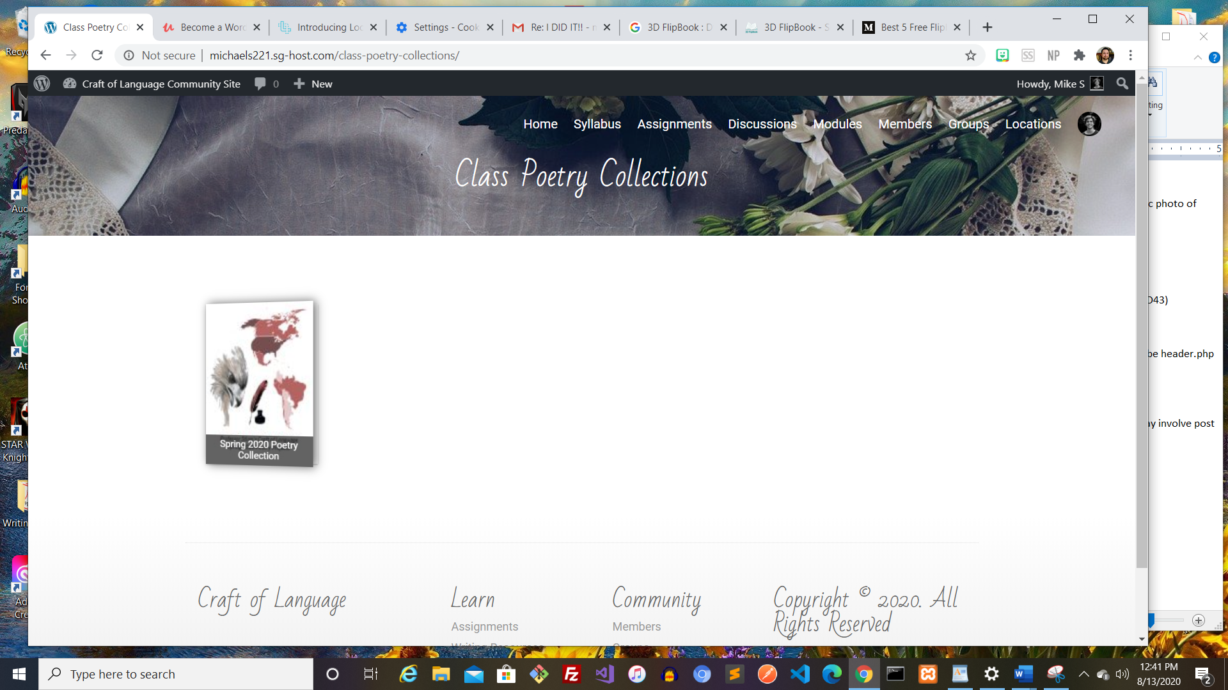

Private GitHub Repository

